

z

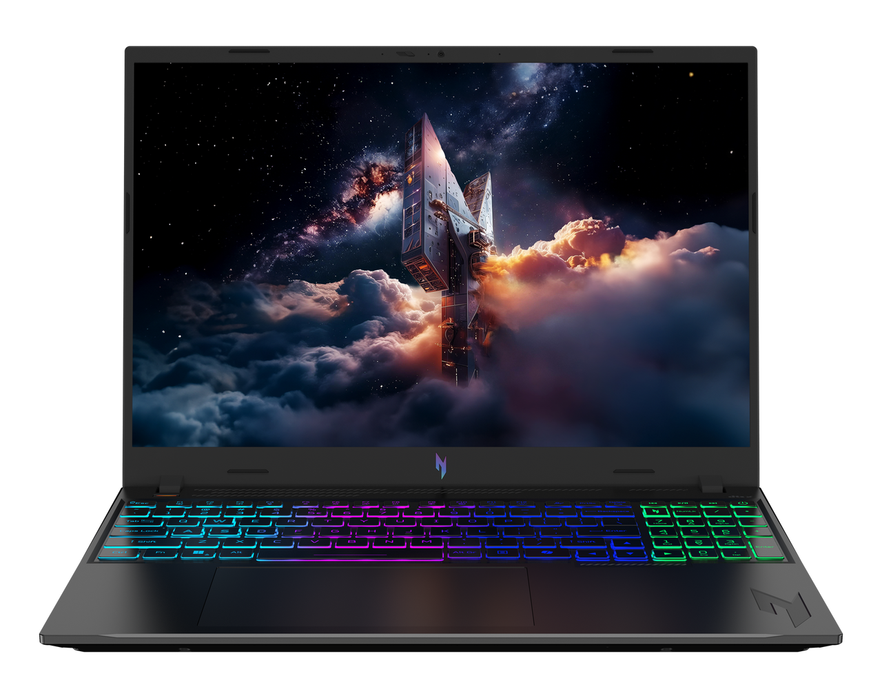

Acer Nitro V 16

SPECIFICATIONS Acer Nitro V 16 ANV16-I31
Acer NITRO V 16S ANV16S-71

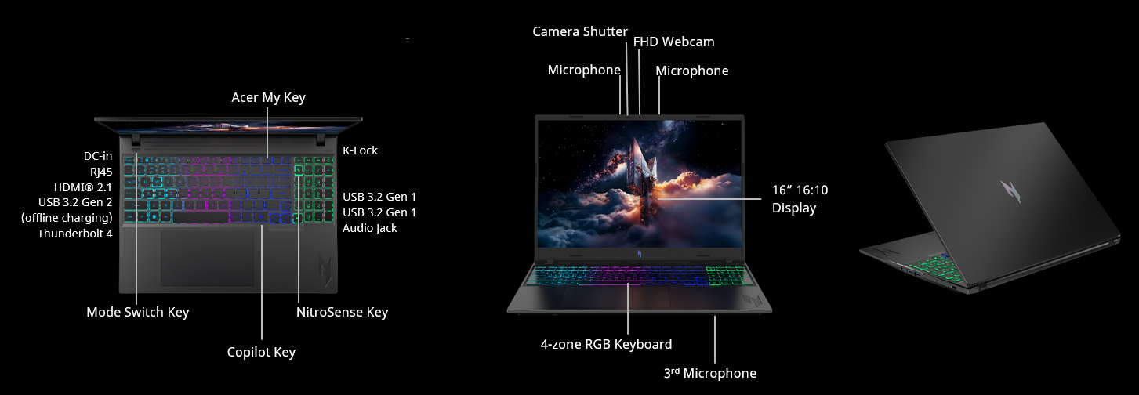
Operating System |  | Windows 11 Home
CPU and Chipset |  | Intel® Core™ 9 processor 270H  Intel® Core™ 7 processor 240H  Intel® Core™ 5 processor 210H
Memory |  | Up to 16 GB of DDR5 system memory  Upgradable to 32 GB using two soDIMM modules |  | Memory Frequency: up to 5600 MT/s: Intel Core 9 processor 270H / Intel Core 7 processor 240H  Memory Frequency: up to 5200 MT/s: Intel Core 5 processor 210H;)
Display |  | 16.0" display with IPS (In-Plane Switching) technology | WUXGA 1920 x 1200 | Acer ComfyView™ LED-backlit TFT LCD | 180 Hz refresh rate | 3 ms grey-to-grey response time with overdrive | NVIDIA® Advanced Optimus capable  16:10 aspect ratio | 100% sRGB color gamut  Wide viewing angle up to 170 degrees  Ultra-slim design  Mercury free, environment friendly |  |  | 16.0" display with IPS (In-Plane Switching) technology | WUXGA 1920 x 1200 | Acer ComfyView™ LED-backlit TFT LCD | 165 Hz refresh rate  16:10 aspect ratio | 45% NTSC color gamut  Wide viewing angle up to 170 degrees  Ultra-slim design  Mercury free, environment friendly |  |  | 16.0" display with IPS (In-Plane Switching) technology | WUXGA 1920 x 1200 | Acer ComfyView™ LED-backlit TFT LCD | 120 Hz refresh rate  16:10 aspect ratio | 100% sRGB color gamut  Wide viewing angle up to 170 degrees  Mercury free, environment friendly
Graphics |  | NVIDIA® GeForce RTX™ 5060 8 GB GDDR7  NVIDIA® GeForce RTX™ 5070 8 GB GDDR7
Audio |  | DTS® X: Ultra Audio, featuring optimized Bass, Loudness, Speaker Protection with up to 6 custom content modes by smart amplifier  High SNR DAC with 2.1 Vrms out capability and can driver high impedance headphone (up to 600 ohm)  Hi-Res Audio Certification by JAS (Headphone Output setting supported up to 24bit /192KHz) |  |  | Supported in Windows Spatial Sound for PC Gaming with DTS  license integrated  Acer Purified Voice technology with AI noise reduction in dual built-in microphones. Features include far-field pickup, dynamic noise reduction through neural network, adaptive beam forming, and predefined personal and conference call modes. |  |  | Immersive audio rendering over headphones and internal speakers  Compatible with Cortana with Voice  Acer TrueHarmony technology for lower distortion, wider frequency range, headphone-like audio and powerful sound
Storage |  | Solid State Drive (2 slots): 512 GB / 1 TB PCIe Gen4, 16 Gb/s, NVMe |  |  | Notes: 1. up to 2TB with two SSD slots | 2. M.2 single-sided 2280
Webcam |  | Video Conferencing  UFC with narrow USB FHD camera | 1920 x 1080 resolution | Dual microphones | Windows compatible
Wireless and Networking |  | WLAN:  Killer™ Wi-Fi 6 AX 1650i  802.11 a/b/g/n+acR2+ax wireless LAN  Dual Band (2.4 GHz and 5 GHz)  2x2 MU-MIMO technology | LAN:  Killer™ Ethernet E2600  10/100/1000 Mbps  Hibernation mode support  Wake On Lan support  IPv4 and IPv6 support |  |  | WPAN:  Supports Bluetooth® 5.2 or above for Wi-Fi 6 wireless card
Security |  | Firmware Trusted Platform Module (TPM) solution | BIOS passwords: User, Supervisor | Kensington lock slot
Dimensions and Weight |  | Dimensions  356.5 (W) x 260 (D) x 11.37/19.9 (H) mm (14.04 x 10.24 x 0.45/0.78 inches) |  |  |  | Weight  2.1 kg (4.63 lbs.) with 4-cell battery pack
Power Adapter and Battery |  | Power Adapter  3-pin 135 W 5.5 PHY PCR 50% AC adapter  19.5 V / 6.92 A as output power  138.0 (W) x 68.5 (D) x 24.5 (H) mm  ​340 g ± 10%, with 180 cm DC cable  Black color with Acer logo  Brick - type AC pins | Battery  76 Wh 4-cell Li-ion battery  For models with WUXGA Panel  Battery life:  Up to 5.5 hours (based on MobileMark® 2030 test results)  Up to 11.5 hours (based on video playback test results)
Input and Control |  | Keyboard  103 (US) / 104 (UK) / 107 (JP) keys | FineTip RGB-backlit keyboard | Independent numeric keypad | International language support  1.5 mm key travel  Special Nitro CMF keycap with transparent side-view for enhanced RGB backlight performance  Caps Lock indicator | Microphone mute indicator | Function Lock key |  |  | Touchpad  Multi-gesture touchpad | Two-finger scroll | Pinch gesture | Gestures to open Cortana | Action Center | Multitasking | Application commands  Microsoft Precision Touchpad certification  Moisture resistant |  | Control Keys  Mode key  NitroSense key  Programmable key | My Key  Microsoft Copilot key
Windows Desktop Apps |  | In-House Applications  Acer ORD Service | Acer QuickPanel | NitroSense V5 (NB) |  |  |  | Tools  Acer My Key Application | Amazon Alexa
Warranty |  | One-year International Travelers Warranty (ITW)
Disclaimers
• | Specifications vary depending on model.
• | Shared system memory may be allocated to support graphics, depending on system memory size and other factors. Actual system memory available to the operating system will be reduced by any memory used by the graphics solution and resources required by the operating environment.
• | Memory speed may vary, depending on the CPU, chipset or memory fitted.
• | All brands and product names mentioned herein include trademarks of their respective companies and are used solely to describe or identify the products.
• | 1 GB is 1 billion bytes. Actual formatted capacity is less and may vary depending on preloaded materials and operating environment. Acer Recovery Management uses a portion of the stated hard disk capacity as dedicated backup space.
• | Minor variations in system dimensions are possible due to the manufacturing process.
• | Weight may vary depending on product configuration, vendor components, manufacturing variability, and selected options.
• | Listed battery life is based on testing using video playback. The test clip loops and continues to run, without interruption or any other inputs, until the battery is drained. Stated battery life is for comparison purpose only. Actual battery life varies by model, configuration, applications, video chip format and features used. A battery's maximum capacity decreases with time and use. Battery life test configuration: Intel® Core™ 7 processor 240H, NVIDIA® GeForce RTX™ 5060, WUXGA, Dual SSD, 32GB of DDR5 memory. Battery life test condition: LCD brightness 150 nits, connected headphones, WLAN off, Bluetooth off and Better Battery Mode on.
• | Actual battery life may vary considerably by specifications, depending on product model, configuration, applications, power management settings, operating conditions, and features utilized. Performance variation also arises based on components in use, which includes but is not limited to the processor, RAM capacity, storage, display and resolution, etc.
• | Bundled software may vary depending on hardware configuration, OS and regional availability.
Product Sheet is based on Nitro ANV16-I31 Specifications (v1-0-0) (Preview)
In a continuing effort to improve the quality of our products, information in this document is subject to change without notice. Images shown are only representations of some of the configurations available for this model. Availability may vary depending on region. As a phenomenon known to thin-film transistors (TFTs), liquid crystal displays (LCDs) commonly exhibit a small number of discoloration dots, as so-called "non-conforming pixels." This phenomenon is a limitation of TFT LCD technology, not a product defect, and as such is not covered by Acer's warranty.
© 2026. All rights reserved.
Microsoft and Windows are registered trademarks of Microsoft Corporation.
3D XPoint, Agilex, Altera, Arc, Arria, Avalon, Axxia, Barefoot Networks, the Barefoot logo, the Footsie logo, Celeron, Cyclone, Docae, DoubleShot, eASIC, easicopy, FlexRAN, Gaudi, Granulate, HyperFlex, Intel, the Intel logo, Intel Adapix, Intel Agilex, Intel Atom, Intel Cofluent, Intel Core, Intel Evo, Intel Geti, Intel Inside, the Intel Inside logo, Intel Optane, Intel RealSense, Intel SpeedStep, Intel Tiber, Intel Unison, Intel vPro, Iris, Killer, Linux, MAX, Movidius, Myriad, Nios, OmniBridge, OpenVINO, the OpenVINO logo, Pentium, Quartus, Simics, SmartByte, SoFiaSilicon, Sound Mark, StarPro, Stay With It, the Engineering Stay With It logo, Stratix, the Stratix logo, the Journey Inside, Thunderbolt, the Thunderbolt logo, Tofino, Ultrabook, VTune, and Xeon are trademarks of Intel Corporation or its subsidiaries.

About Acer
Founded in 1976, Acer is one of the world's top ICT companies with a presence in more than 160 countries. As Acer evolves with the industry and changing lifestyles, it is focused on enabling a world where hardware, software and services will fuse with one another, creating ecosystems and opening up new possibilities for consumers and businesses alike. Acer's 7,500 employees are dedicated to the research, design, marketing, sale, and support of products and solutions that break barriers between people and technology. Please visit www.acer.com for more information.

